Corporal punishment of children in Svalbard
LAST UPDATED June 2019  Also available online at www.endcorporalpunishment.org  Child population [not available] | 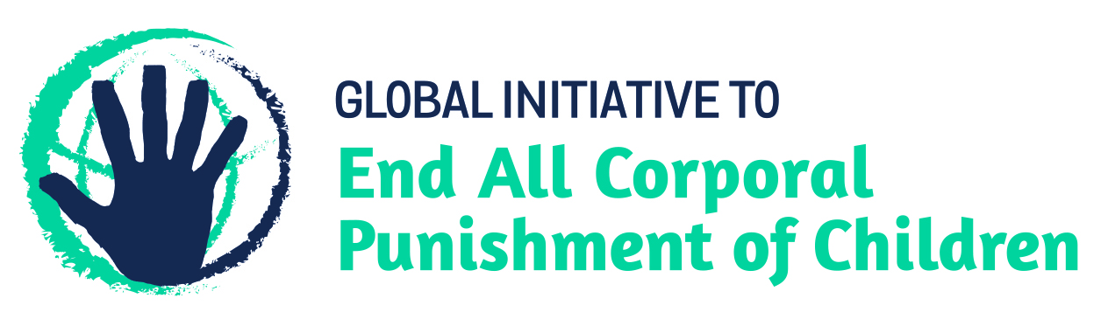

Law reform has been achieved. Corporal punishment is unlawful in all settings, including the home.

Note: Svalbard is part of the Kingdom of Norway. The civil and criminal law of Norway applies.

Prohibition of corporal punishment

Home
Corporal punishment is prohibited in the home. The 1926 right of parents to use moderate physical punishment was removed from the Criminal Code in 1972. The Parent and Child Act (the Children Act) 1981 was amended in 1987 to state (art. 30): “The child must not be subjected to violence or in any other way be treated so as to harm or endanger his or her mental or physical health.” This was interpreted as prohibiting all corporal punishment of children. However, in 2005, while upholding the conviction of a man under the Penal Code for smacking his stepsons on their bare bottoms with his hand, the Supreme Court stated that lighter smacks would be permitted. Following a review of the law, further amendments to legislation were passed in April 2010 which confirm prohibition of all corporal punishment. Article 30(3) of the Act, as amended in 1987 and again in 2010, now states: “The child must not be exposed to violence or otherwise be treated so that its physical or mental health is endangered. This includes violence used in raising the child. The use of violence and frightening, harassing or otherwise inconsiderate behaviour towards the child is forbidden.”

Alternative care settings
Corporal punishment is unlawful in alternative care settings under the Parent and Child Act 1981 as amended 1987 and 2010 (see under “Home”).

Day care
Corporal punishment is unlawful in early childhood care and in day care for older children under the Parent and Child Act 1981 as amended in 1987 and 2010 (see under “Home”).

Schools
Corporal punishment has been unlawful in schools since 1936, but we have no details of prohibiting legislation.

Penal institutions
Corporal punishment is unlawful as a disciplinary measure in penal institutions, but we have no details of prohibiting legislation.

Sentence for crime
Corporal punishment is unlawful as a sentence for crime. It is not among permitted sentences in the Criminal Code.

Universal Periodic Review of Norway’s human rights record
Norway was examined in the first cycle of the Universal Periodic Review in 2009 (session 6). No recommendations were made concerning corporal punishment of children.
Examination in the second cycle took place in 2014 (session 19). No recommendations were made on corporal punishment of children.
Third cycle examination took place in 2019 (session 33). No recommendations were made on corporal punishment of children.

Recommendations by human rights treaty bodies
Note: It appears the Convention on the Rights of the Child, the Convention Against Torture and Other Cruel, Inhuman or Degrading Treatment or Punishment, the International Covenant on Civil and Political Rights, the International Covenant on Economic, Social and Cultural Rights, the Convention on the Elimination of All Forms of Discrimination Against Women, and the Convention on the Rights of Persons with Disabilities all apply in Svalbard, as they do in Norway. The European Social Charter does not apply.

Committee on the Rights of the Child
(21 September 2005, CRC/C/15/Add.263, Concluding observations on third report, paras. 27 and 28)
“The Committee is concerned that children who are exposed to violence within the family do not always receive sufficient care and assistance.
“The Committee recommends that the State party continue to strengthen its efforts to provide adequate assistance to children who are exposed to violence within the family or whose parents are psychiatric patients and/or drug abusers, including through: ...
d) public education campaigns about the negative consequences of ill-treatment and preventive programmes, including family development programmes promoting positive, non-violent forms of discipline.”

Human Rights Committee
(18 November 2011, CCPR/C/NOR/CO/6, Concluding observations on sixth report, para. 3)
“The Committee welcomes the following legislative and institutional steps taken by the State party:
(i) The amendments to the Children Act in 2010 to proscribe light forms of corporal punishment....”

Prevalence/attitudinal research in the last ten years
None identified.

End Corporal Punishment is a critical initiative of the Global Partnership to End Violence Against Children. Previously known as The Global Initiative to End All Corporal Punishment of Children, we act as a catalyst for progress towards universal prohibition and elimination of corporal punishment of children. We track global progress, support and hold governments to account, partner with organisations at all levels, and engage with human rights treaty body systems.

30 November 2005, HR-2005-01865-A

