Corporal punishment of children in Greenland
LAST UPDATED October 2017  Also available online at www.endcorporalpunishment.org  Child population [not available] | 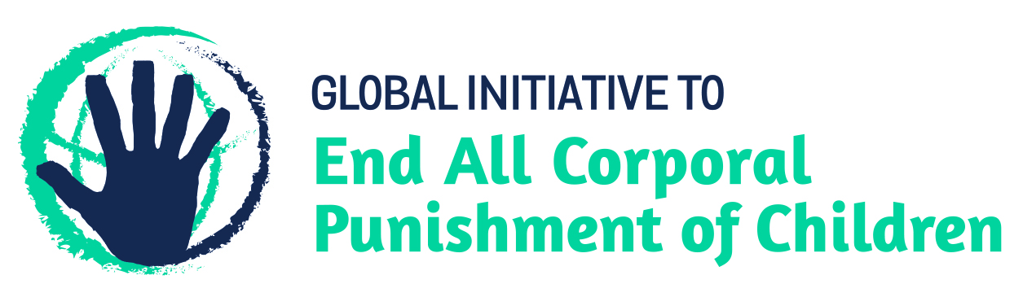

Law reform has been achieved. Corporal punishment is unlawful in all settings, including the home.

Note: Greenland is a self-governing country within the Kingdom of Denmark. On 21 June 2009, the Act on Greenland Self-Government came into force, replacing the Greenland Home Rule Act of 29 November 1978 and providing for increased autonomy for Greenland.

Prohibition of corporal punishment

Home
Corporal punishment is unlawful in the home. In January 2016, the Greenlandic Parliament (Folketinget) passed Bill No. L 35 – the Law amending the authority of the law for Greenland, the Act on the entry into force for Greenland of the Act on legal effects of marriage, the Code of Greenland and the Greenland Criminal Code. The new Law comes into effect in April 2016, when it will bring into force in Greenland the Danish Act on Parental Responsibility 2007, article 2(2) of which prohibits corporal punishment of children: “Children have the right to care and security. Children must be treated with respect for their person and must not be exposed to corporal punishment or other humiliating treatment.” The prohibition is applicable to all persons with parental authority, including not only the family home but also alternative care settings and all forms of day care.
The commentary which accompanied the L35 Bill as submitted to parliament confirms in section 3.3.1 that one of its purposes is to prohibit all corporal punishment of children and that with the enactment of prohibition the use of corporal punishment is punishable under the provisions on violence in article 88 of the Criminal Code of Greenland. In tabling the Bill in parliament in October 2015, Minister for Social Security and the Interior confirmed that the Bill repeals the right of parents to “chastise” their children.

Alternative care settings
Corporal punishment is prohibited in foster homes run by the Home Rule under the Home Rule executive order on foster homes 1996. Until reform in 2016, the legality of corporal punishment in private and municipal homes was unclear, although these should be supervised by Home Rule authorities, and there was no explicit prohibition in relation to other alternative care settings. With the 2016 reform, corporal punishment is unlawful in all alternative care settings under the Danish Act on Parental Responsibility 2007, in force in Greenland from April 2016.

Day care
Corporal punishment is unlawful in alternative care settings. The prohibition of corporal punishment in the Danish Act on Parental Responsibility 2007 applies to all persons with parental authority over children. It comes into effect in Greenland in April 2016.

Schools
Corporal punishment is prohibited in public and private schools by Home Rule Order No. 11 of 14 May 2003.

Penal institutions
Corporal punishment is considered unlawful as a disciplinary measure in penal institutions, though there appears to be no explicit prohibition. Existing rules reportedly allow the use of force in residential institutions for children only for purpose of restraint and for moving a child to a different room.

Sentence for crime
Corporal punishment is unlawful as a sentence for crime. There is no provision for judicial corporal punishment in the Criminal Code and the Administration of Justice Act 2010.

Universal Periodic Review of Denmark’s human rights record
Denmark was examined in the first cycle of the Universal Periodic Review in 2011 (session 11). No recommendations were made specifically concerning corporal punishment of children. However, the following recommendation was made and was accepted by the Government:
“Continue its efforts to combat domestic violence, especially against vulnerable groups such as women and children (Republic of Korea);
“Establish specific mechanisms and formulate specific programmes geared to addressing the issue of violence against women and children, including by harmonizing national legislation with international human rights standards (Indonesia)”
Examination in the second cycle took place in 2016 (session 24). No recommendations were made specifically on corporal punishment of children. The Government informed the UPR that prohibition was expected to be achieved in Greenland in 2016.

Recommendations by human rights treaty bodies
Note: It appears the Convention on the Rights of the Child, the Convention Against Torture and Other Cruel, Inhuman or Degrading Treatment or Punishment, the International Covenant on Civil and Political Rights, the International Covenant on Economic, Social and Cultural Rights, the Convention on the Elimination of All Forms of Discrimination Against Women and the Convention on the Rights of Persons with Disabilities all apply in Greenland, as they do in Denmark. The European Social Charter does not apply.

Committee on the Rights of the Child
(29 September 2017, CRC/C/DNK/CO/5, Concluding observations on fifth report, Advance unedited version, para. 18)
“While noting with appreciation that corporal punishment is unlawful, the Committee, in view of reports that violence against children within the family continues to occur, draws the State party’s attention to its general comment No. 8 (2006) on corporal punishment and recommends that the State party:
(a) Increase its efforts to raise awareness about the unlawfulness of violence against children, including corporal punishment, and adequately implement this prohibition, and, in collaboration with the media and the education sector, ensure that children are informed about their right to be free from violence;
(b) Promote positive, non-violent and participatory forms of child-rearing and discipline and provide support to parents who have problems with their childrearing duties.”

Committee on the Rights of the Child
(7 April 2011, CRC/C/DNK/CO/4, Concluding observations on fourth report of Denmark, paras. 38 and 39)
“The Committee notes with concern that corporal punishment is lawful in the home and in alternative care settings in the Faroe Islands and that, although Government Circular No. 1 on School Discipline (12 January 1994) states that corporal punishment should not be used, there is no explicit prohibition in law.
“The Committee urges the State party to take measures to ensure that corporal punishment is prohibited in all settings and throughout its territory and to conduct awareness-raising and public education programmes with a view to encouraging the use of alternative disciplinary measures in line with the inherent dignity of the child, while taking due account of the Committee’s general comment No. 8 (2006) on the right of the child to protection from corporal punishment and other cruel or degrading forms of punishment.”

Committee on the Rights of the Child
(10 July 2001, CRC/C/15/Add.151, Concluding observations on second report of Denmark, para. 6)
“The Committee notes with satisfaction that in 1997, the right of parents to use corporal punishment on their children was abolished by law. The Committee expresses further satisfaction at the nationwide awareness raising campaign undertaken to inform parents about the new legislation. The Committee notes the efforts to include material in minority languages as a follow-up to the campaign.”

Committee on Economic, Social and Cultural Rights
(6 June 2013, E/C.12/DNK/CO/5, Concluding observations on fifth report, para. 14)
“The Committee is concerned that corporal punishment of children is not explicitly prohibited in Greenland regarding the home and other care settings (art. 10).
The Committee recommends that the State party take steps to ensure that corporal punishment is prohibited in all settings in Greenland.”

Prevalence/attitudinal research in the last ten years
None identified.

End Corporal Punishment is a critical initiative of the Global Partnership to End Violence Against Children. Previously known as The Global Initiative to End All Corporal Punishment of Children, we act as a catalyst for progress towards universal prohibition and elimination of corporal punishment of children. We track global progress, support and hold governments to account, partner with organisations at all levels, and engage with human rights treaty body systems.

22 January 2010, CRC/C/DNK/4, Fourth report to the Committee on the Rights of the Child, para. 853
11 July 2011, A/HRC/18/4, Report of the working group, paras. 106(83) and 106(86)
1 February 2016, A/HRC/WG.6/24/L.7 Unedited Version, Draft report of the working group, para. 118

